PCA vs Raw Features: Does Dimensionality Reduction Improve Classification?
Dataset: Breast Cancer Dataset

1. Introduction
Machine learning models often rely on datasets that contain many features describing each observation. While many variables can provide valuable information, high-dimensional datasets can also create challenges for data analysis and predictive modelling. High dimensionality may introduce redundant information, increase computational complexity, and make interpretation more difficult.

Dimensionality reduction techniques aim to address these challenges by transforming the original feature space into a smaller set of variables that preserve the most important information in the dataset. One of the most widely used dimensionality reduction methods is Principal Component Analysis (PCA).

Principal Component Analysis converts many correlated variables into a smaller number of uncorrelated components known as principal components. These components capture the directions of maximum variance in the data.

Although PCA is commonly used for visualization and data compression, an important question remains: does dimensionality reduction improve classification performance?

This tutorial investigates that question by comparing the performance of a classification model trained on raw features with a model trained on PCA-transformed features. The analysis uses the Breast Cancer dataset and evaluates how dimensionality reduction affects model accuracy and interpretability.

2. High-Dimensional Data and the Need for Dimensionality Reduction
Datasets that have many features often referred to as high-dimensional datasets. Several problems arise when you have more dimensionality. One issue is the curse of dimensionality, which makes it difficult to analyse the data stored in a high-dimensional space.

When the number of features grows, data points become sparser in the feature space. This can reduce the effectiveness of machine learning models because identifying meaningful patterns becomes more difficult

Features repeating themselves is another issue. There are many datasets that have strong correlations among the variables. This redundancy can add noise and reduce efficiency in models. To deal with issues related to ‘curse of dimensionality’, valuable information can be obtained by compressing the data to a lesser set of variables.

3. Principal Component Analysis
PCA is a technique to reduce dimensionality of data set. It is an unsupervised statistical technique. PCA changes the initial features into an innovative coordinating system where the axes show maximum variance directions.
Each principal component is a linear combination of the original variables. The components are ordered according to the amount of variance they capture from the dataset.

The largest possible variance of the data is captured by the first principal component. The next largest variance is captured by the second principal component which is orthogonal to the first. More process carries on this.

By selecting only the first few principal components, it is possible to represent most of the dataset’s variation using far fewer variables. This transformation enables dimensionality reduction while retaining important information.

4. Dataset Description
The Breast Cancer Wisconsin Diagnostic Dataset will be utilized in this tutorial and it is available via the scikit-learn machine learning library. The dataset consists of diagnostic measurements derived from digitized images of breast tissues. The measurements describe the characteristics of cell nuclei extracted from medical images.

The dataset includes 30 numerical features that capture properties such as:
- radius
- texture
- perimeter
- area
- smoothness
- concavity
- symmetry
The target variable indicates whether the tumour is malignant (cancerous) or benign (non-cancerous).
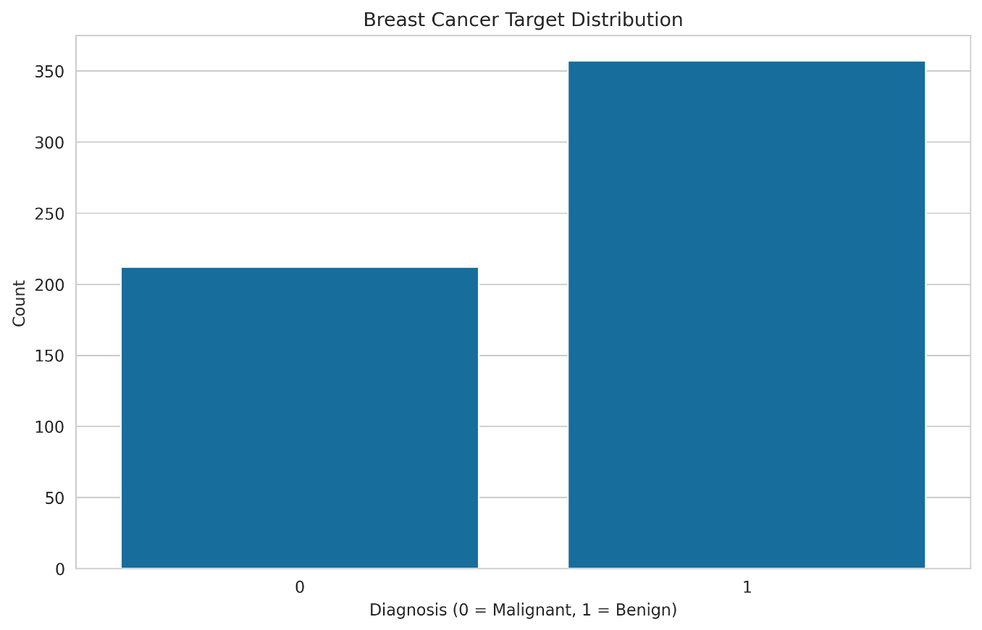

Because the dataset contains many correlated variables, it provides a suitable case for studying the effects of dimensionality reduction using PCA.

5. Data Preparation
Before PCA, it is necessary to pre-process the data set so that all the variables are measured at the same scale. Due to variance calculations, PCA’s feature scaling sensitivity is real. To resolve this problem, z-score normalisation was used to standardise the features. When used in the context of a dataset, standardization refers to the transformation of each feature to ensure that it has a mean of zero and a unit standard deviation.

After normalization, the dataset was split into training and testing. The classification models were trained using training set and evaluated using testing set for measuring model performance.
6. Baseline Classification Using Raw Features
To establish a baseline performance level, a Logistic Regression classifier was trained using the original standardized features. Logistic regression is a commonly used classification algorithm that models the probability of a binary outcome. It is particularly suitable for medical datasets because of its interpretability and stability.
The model that was, trained using some raw features, achieved good classification accuracy, testing dataset. The data set of breast cancer contains predictive features as demonstrated by this result. The dataset still has a lot of variables which might lead to redundancy.
7. PCA Dimensionality Reduction
Principal Component Analysis was applied to the standardized dataset to reduce dimensionality.
The cumulative explained variance analysis was used to determine how many components are required to capture most of the dataset's variance.
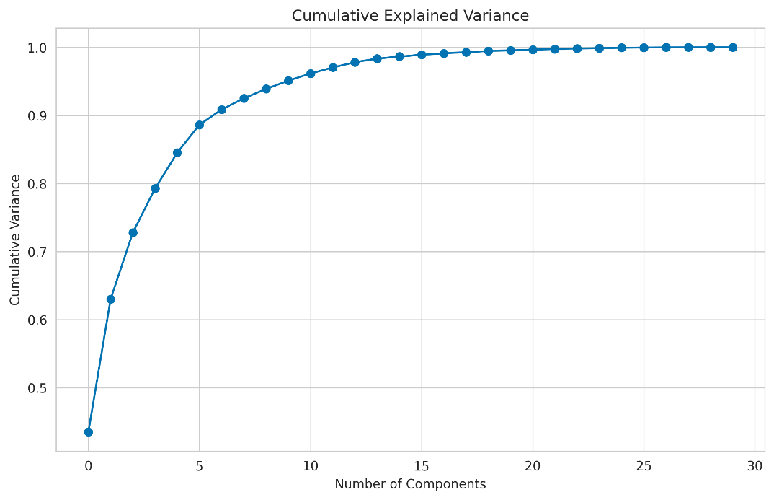
The results indicate that a relatively small number of components can represent most the dataset's information. In this tutorial, the number of components was selected to retain approximately 95% of the total variance. This reduces the number of variables while preserving most of the original information.
8. Visualizing PCA Transformation
To better understand how PCA transforms the dataset, the samples were projected into the first two principal components.
The visualization shows that the malignant and benign tumour samples form distinguishable clusters in the principal component space. Even though the original dataset contains 30 features, the first two components capture enough information to reveal meaningful separation between classes.

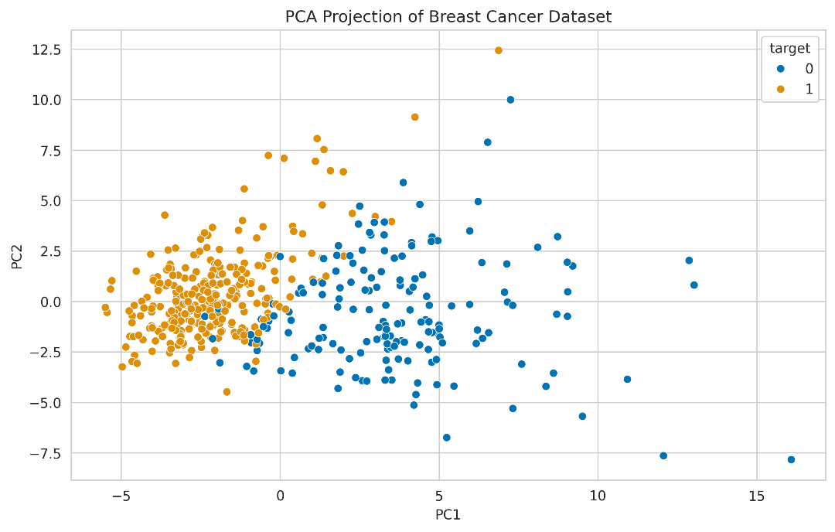
9. Variance Contribution of Principal Components
Understanding how much variance each component captures is essential for interpreting PCA.
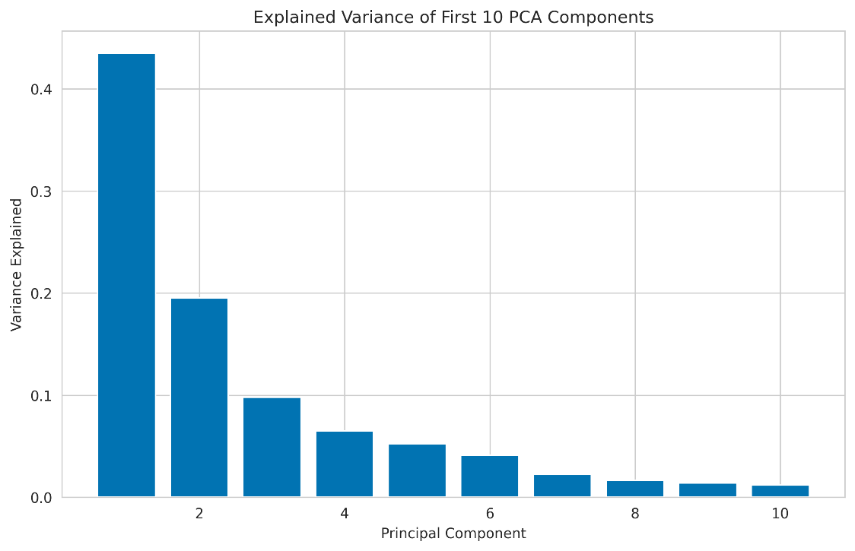
The explained variance plot illustrates the contribution of individual components to the dataset's total variance.
Model Performance Comparison
To investigate whether dimensionality reduction improves classification performance, two models were trained:
- Logistic regression using the original standardized features
- Logistic regression using PCA-transformed features

Both models were evaluated using the testing dataset. The classification accuracy of each model was then compared.

The results show that the PCA-based model achieves performance comparable to the model trained on raw features. This indicates that the reduced feature set still contains sufficient information for accurate classification.
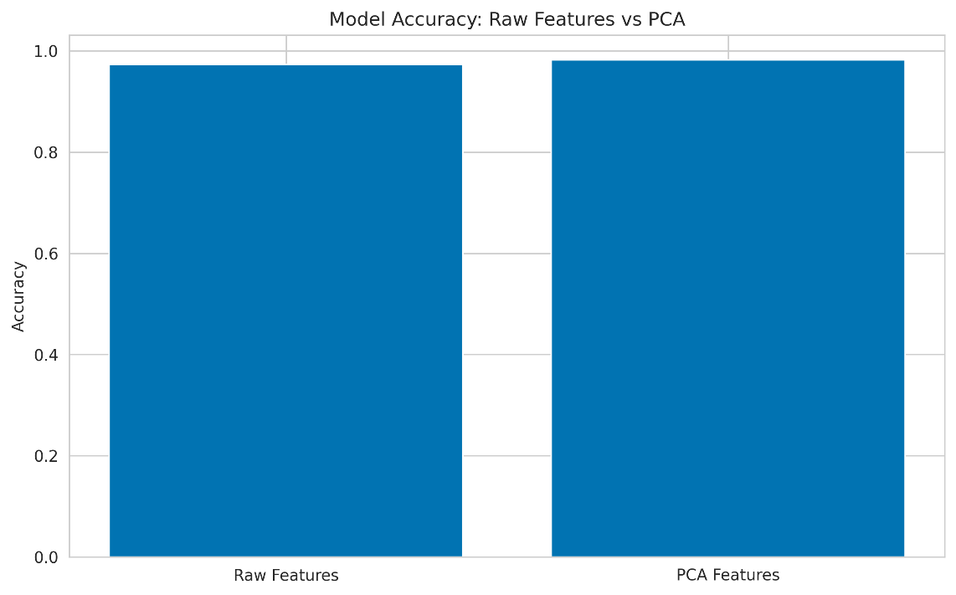
Feature Contribution Interpretation
Understanding how the original features contribute to the principal components provides additional insight into the PCA transformation.

Each principal component is formed from a linear combination of the original variables. The coefficients of these combinations are known as component loadings. These loadings indicate how strongly each variable influences a particular component.
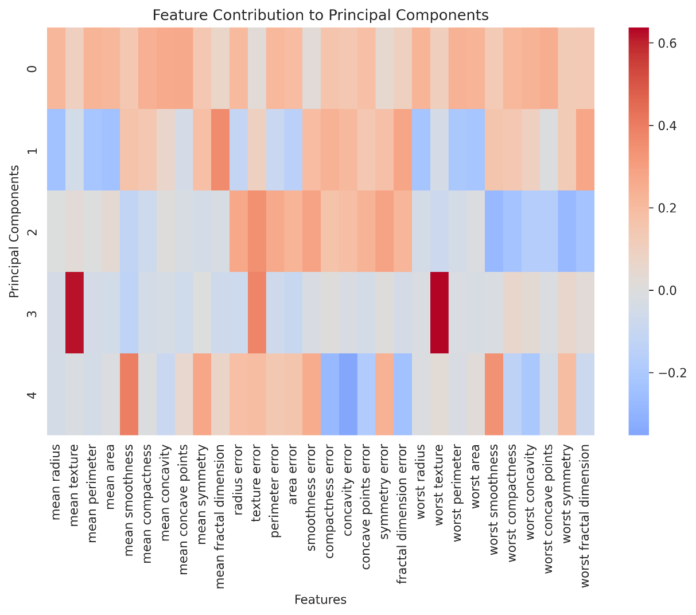
The heatmap highlights which variables contribute most strongly to each component. This information can help interpret the meaning of the principal components and identify which features play an important role in shaping the dataset's structure.
Model Evaluation
To further evaluate model performance, a confusion matrix was generated for the PCA-based classifier.
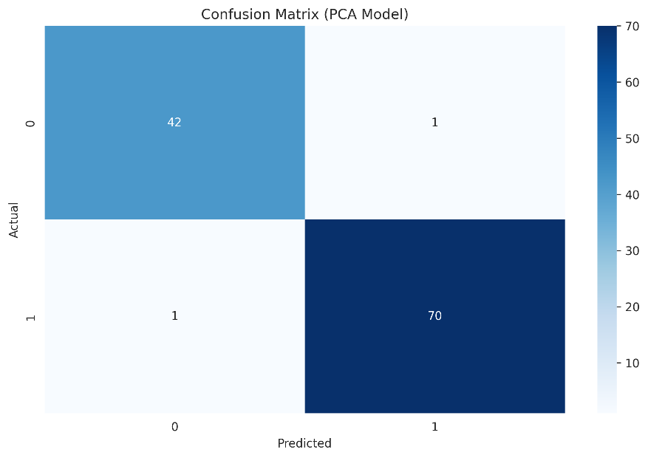
Discussion
- The findings presented in this study offer multiple insights into the utility of dimensionality reduction in classification tasks.

- Initially, PCA caused sharp decreases in features from 30 to less while keeping more of the dataset’s variability. This shows that a lot of the original variables contain overlap of information.

- In addition, the classification accuracy of the PCA-based model was comparable to the model that used the original features. As a result, reducing the dimensions didn’t lower the predictive power.

- To conclude, the useful visualizations from PCA also helped uncover patterns that are not immediately visible to the naked eye.

The result shows that PCA can simplify our dataset with ease and make them more interpretable.
Conclusion
We’ll explore whether PCA gives better classification results than raw features, which was the aim of this tutorial with code. The analysis reveals the following key findings.

- The Breast Cancer dataset's 30 correlated attributes were transformed into principal components of smaller dimensions, using Principal Component Analysis.

- Through cumulative variance analysis, it was observed that a small number of components may be adequate to retain most of the information of the dataset; e.g. the variance may be retained at about 95% on using a small number of features only.

- Looking at the two principal components in which we visually represented our dataset, we can see that malignant and benign tumour samples are clustered away from one another with some degree of overlap.

- Both the Logistic Regression model using features without PCA and the model using features with PCA show similar classification outcomes, representing that dimensionality reduction did not hinder the model predictively.

- PCA brought only slight improvements in classification accuracy, but it did simplify our dataset while preserving key patterns and relationships.

- The results show that PCA is an excellent strategy for boosting visualization through feature dimensionality reduction, besides simplifying the whole machine learning process with almost no hit on performance.
Future Work
There are several ways that the analysis in this tutorial could be extended.
- Other dimensionality reduction techniques such as t-SNE, UMAP, or Kernel PCA can be investigated as alternatives to PCA.

- Checking how PCA can change model performance. For example, using PCA with Support Vector Machines, Random Forests or Gradient Boosting models.

- How decreasing dimensionality affects model performance on larger and more complex datasets.

- The goal is to determine if PCA improves training speed and computational performance when dealing with high dimensional datasets.

- The study will be extended to cross validation experiments to get more robust estimates of classification performance.

References
Jolliffe, I. and Cadima, J. (2016) Principal Component Analysis: A Review and Recent Developments. Philosophical Transactions of the Royal Society A, 374(2065).

Pedregosa, F. et al. (2011) Scikit-learn: Machine Learning in Python. Journal of Machine Learning Research, 12, pp. 2825–2830.

Géron, A. (2022) Hands-On Machine Learning with Scikit-Learn, Keras and TensorFlow. O’Reilly Media.

Scikit-learn Developers (2024) Breast Cancer Dataset Documentation. Available at:
https://scikit-learn.org/stable/modules/generated/sklearn.datasets.load_breast_cancer.html

